**AGGREGATE FUCTION**

use comp;

db.createCollection('website');

db.website.insert({'roll':'1','name':'harsh','amount':1000,'url':'www.yahoo.com'});

db.website.insert({'roll':'2','name':'jitesh','amount':2000,'url':'www.yahoo.com'});

db.website.insert({'roll':'3','name':'rina','amount':3000,'url':'www.google.com'});

db.website.insert({'roll':'4','name':'ash','amount':4000,'url':'www.gmail.com'});

db.website.insert({'roll':'5','name':'ash','amount':1000,'url':'www.pvg.com'});

//SUM AGGREGATE



//AVG AGGREGATE



//MIN AGGREGATION



//MAX AGGREGATION

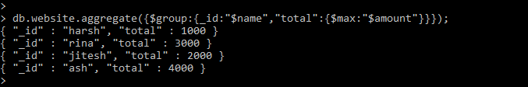

//FIRST AGGREGATION



//LAST AGGREGATION



//PUSH AGGREGATION



//COUNT AGGREGATION



//ADDTOSET AGGREGATE

